Christopher Greenman
Work for the Wiregrass Museum’s Art Biennial 22

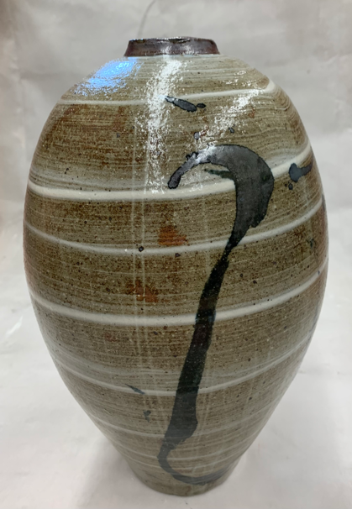
Large Egg Vase, stoneware, 2021, 13x 7 x 7 , $265.00

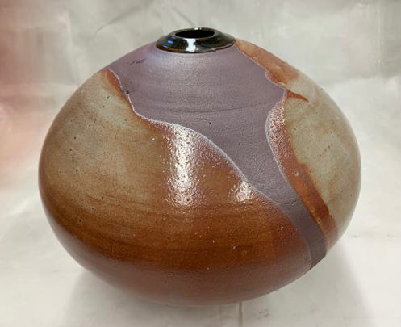
- Large Sphere, stoneware, 2021 12x 13 x 13”, $250.00
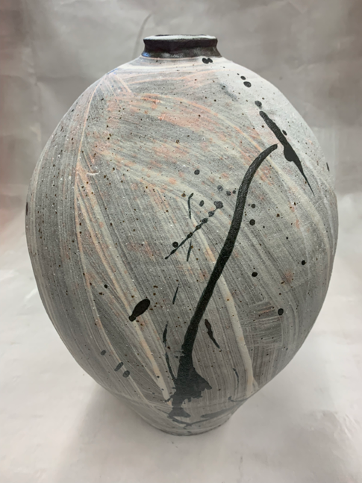

- Large Egg Vase, stoneware, 2021,14x 9x9”, $230.00

