B22 Wiregrass Biennial Image Checklist
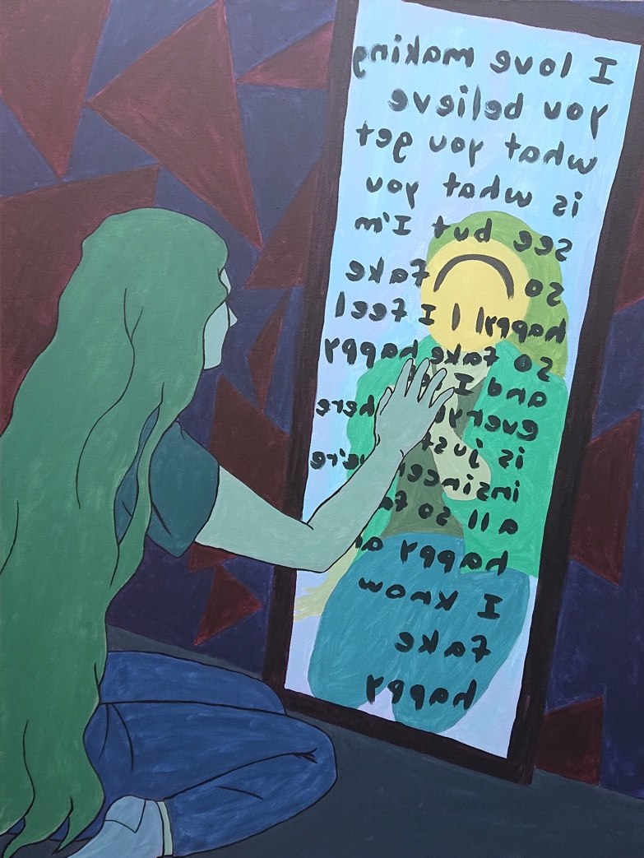
Fake Happy, 2020, 36x48”, acrylic on canvas, $500 (price and insurance value)
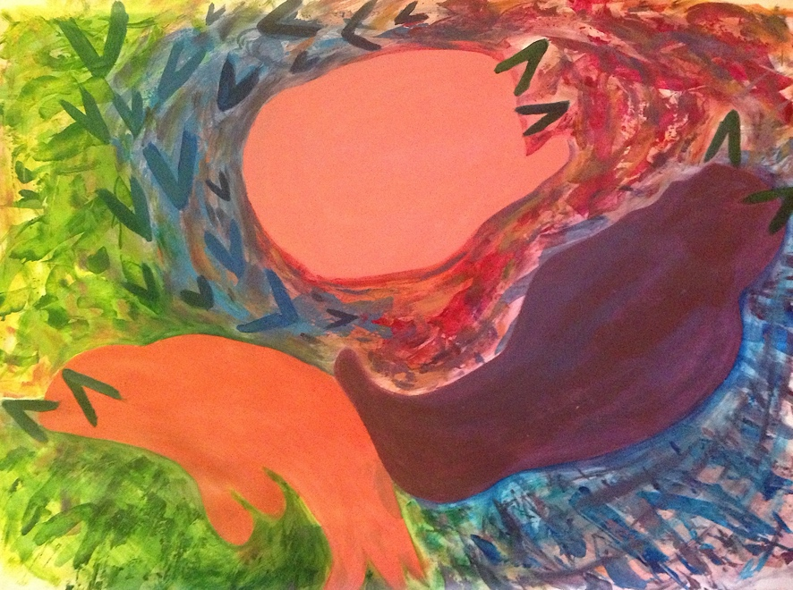
Three (Blobs) Cats, 2019, 22x30”, acrylic on paper, $300 (price and insurance value)
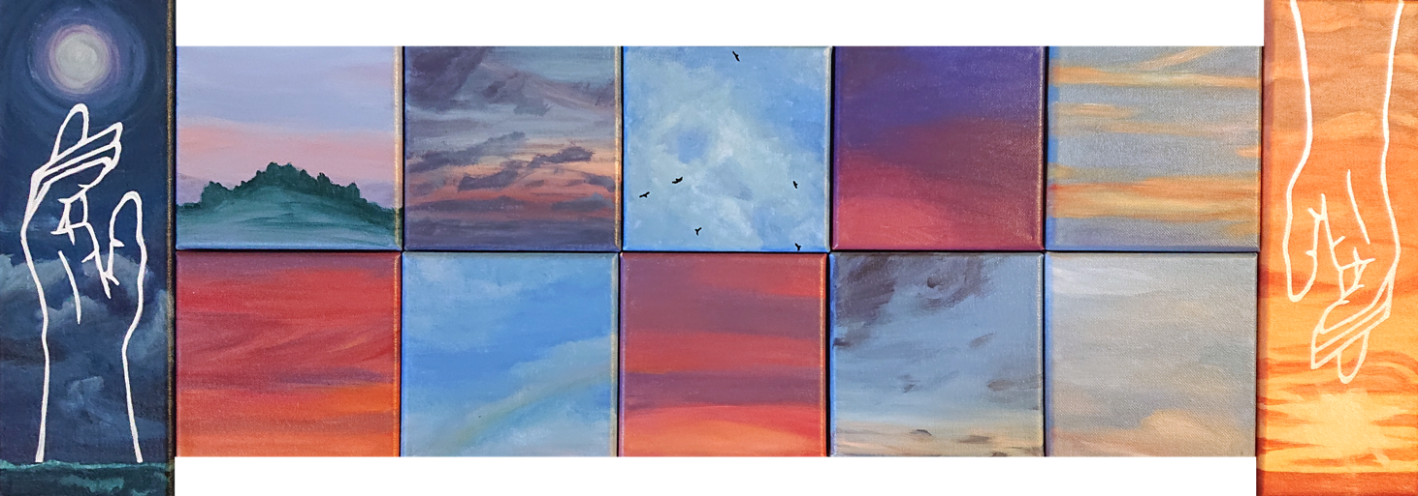
Rise and Set, 2019, 33x12”, acrylic and oil paint marker on 12 canvases, $400 (price and insurance value)

