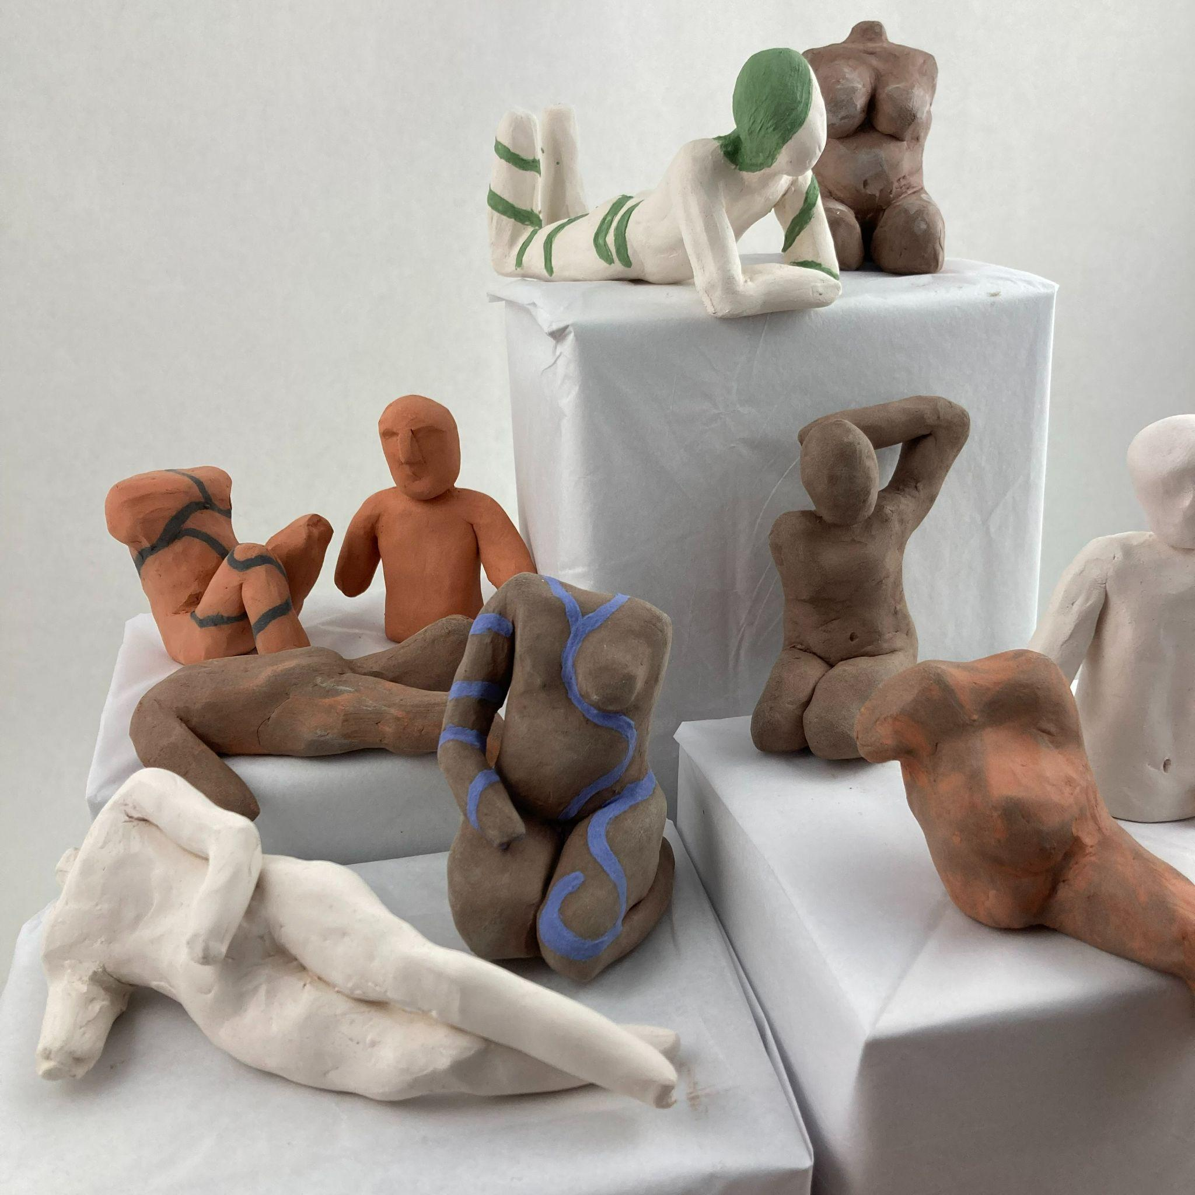
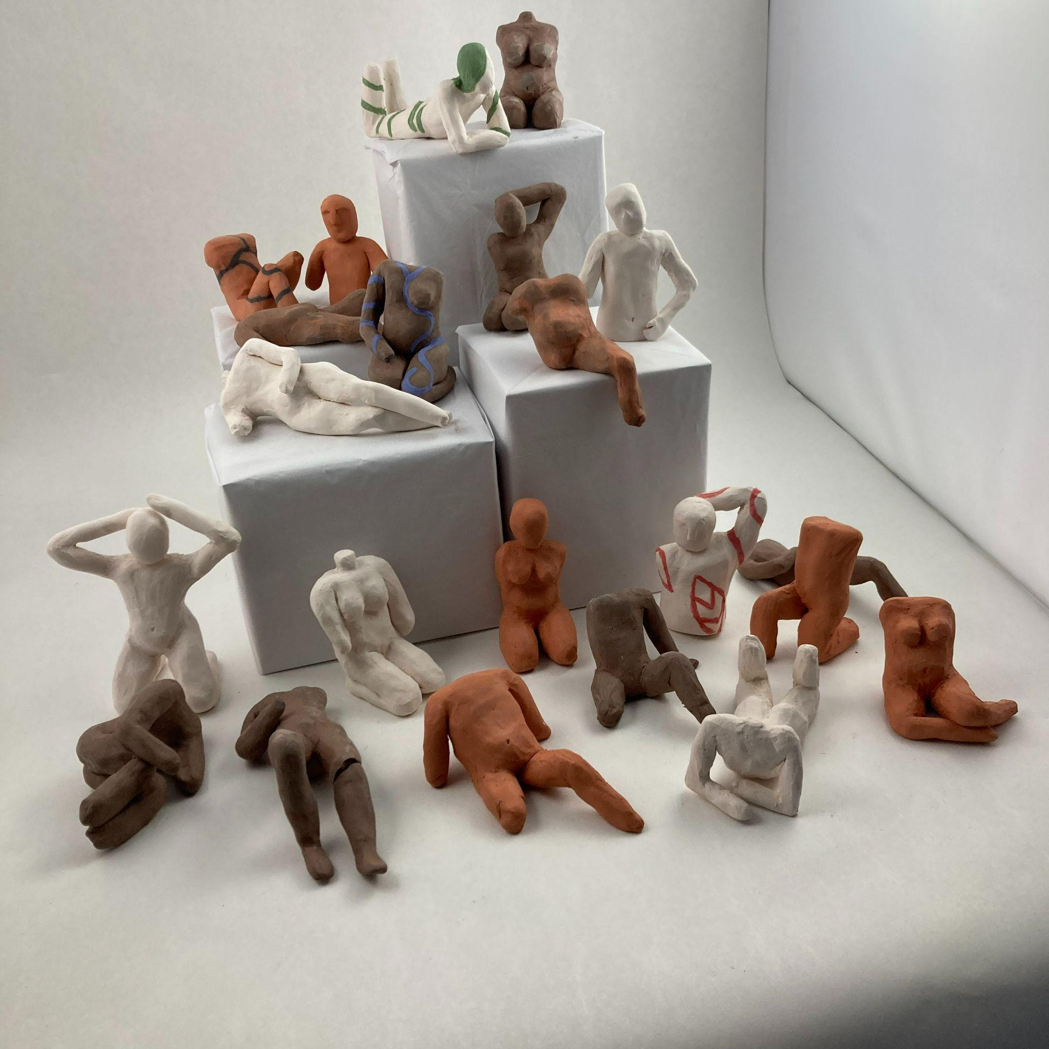

Cereal Aisle: Detail Photo

Cereal Aisle
Ceramic with underglaze
2021
NFS

