FRAHN KOERNER
____________________________________________________________________________________________________________
New Orleans, Louisiana 70118 USA
MOBILE: 504 261 7227
EMAIL: frahnkoerner@gmail.com
www.frahnkoerner.com

2020 – 21 Portrayals
- 2021, Untitled for Now
2021.2.3
Acrylic on Yupo paper
26 x 20 inches
32 x 25 inches framed
$1,250
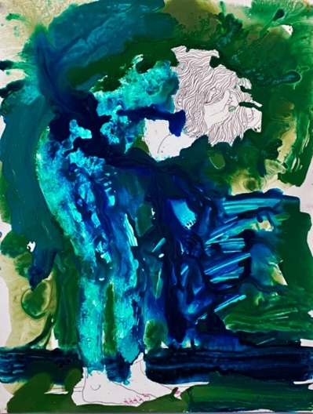

- Unwavering Fervor
2021.5.17
Acrylic on Yupo paper
26 x 20 inches
32 x 25 inches framed
$1,250
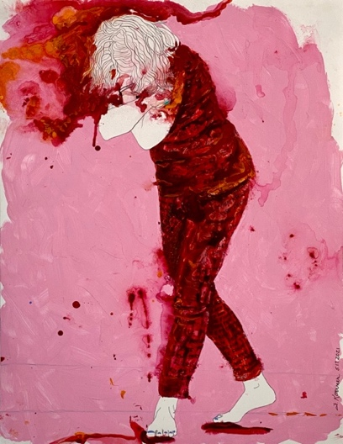

- Before the Dawn
2021.5.26
Acrylic on Yupo paper
26 x 20 inches
32 x 25 inches framed
$1,250
